EXPERIMENT 7
Aim : To study Exception Handling
Theory:
Exceptions are runtime anomalies or abnormal conditions occur while executing a program.
An exception is a problem that arises during the execution of a program. A C++ exception is a response to an exceptional circumstance that arises while a program is running, such as an attempt to divide by zero.
Exceptions provide a way to transfer control from one part of a program to another. C++ exception handling is built upon three keywords: try, catch, and throw.
- throw − A program throws an exception when a problem shows up. This is done using a throw keyword.
- catch − A program catches an exception with an exception handler at the place in a program where you want to handle the problem. The catch keyword indicates the catching of an exception.
- try − A try block identifies a block of code for which particular exceptions will be activated. It's followed by one or more catch blocks.
Throwing Exceptions
Exceptions can be thrown anywhere within a code block using throw statement. The operand of the throw statement determines a type for the exception and can be any expression and the type of the result of the expression determines the type of exception thrown.
Catching Exceptions
The catch block following the try block catches any exception. You can specify what type of exception you want to catch and this is determined by the exception declaration that appears in parentheses following the keyword catch.
Errors can be broadly categorized into two types. We will discuss them one by one.
- Compile Time Errors
- Run Time Errors
Compile Time Errors – Errors caught during compiled time is called Compile time errors. Compile time errors include library reference, syntax error or incorrect class import.
Run Time Errors - They are also known as exceptions. An exception caught during run time creates serious issues.
Errors hinder normal execution of program. Exception handling is the process of handling errors and exceptions in such a way that they do not hinder normal execution of the system. For example, User divides a number by zero, this will compile successfully but an exception or run time error will occur due to which our applications will be crashed. In order to avoid this we'll introduce exception handling technics in our code.

Write a C++ program to implement exceptional handling concept (Divide by zero) using exception rethrow mechanism

#include<iostream>
using namespace std;

template<class T>
void div(T a,T b)
{
try{

if(b==0)
{
throw b;
}
else {
cout<<"Res: "<<(a/b)<<endl;
}
}
catch (T b){
cout<<"Rethrowing"<<endl;
throw ;
}
}
int main()
{
int a,b;
float x,y;
cout<<"Enter two int nos"<<endl;
cin>>a>>b;
cout<<"Enter two float nos"<<endl;
cin>>x>>y;

try{
div<int>(a,b);
div<float>(x,y);

}
catch(int a)
{
cout<<"Caught!! Denominator is zero for integers||"<<endl;
}
catch(float b)
{
cout<<"Caught!! Denominator is zero for floats||"<<endl;
}
}
OUTPUT:

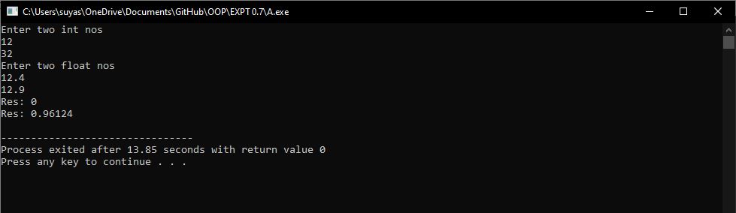

Write a C++ program to implement a multi catch exception handling mechanism

#include<iostream>
#include<iomanip>
#include<exception>
#include<fstream>
using namespace std;
void social(char *name,int age, char div)
{
int m=0,n,s=0;
if(name==NULL)
{
throw(name);
return;
}
if(div!='A'&&div!='B' )
{
throw(div);
return;
}
cout<<"Enter no of subjects"<<endl;
cin>>n;
cout<<"Enter Marks of "<<n<<" subjects"<<endl;
for(int i=0;i<n;i++)
cin>>m,s=s+m;
if(n==0)
{
throw(n);
return;
}

cout<<"Name: "<<setw(15)<<right<<name<<endl;;
cout<<"Age: "<<setw(15)<<right<<age<<endl;
cout<<"Div: "<<setw(15)<<right<<div<<endl;
cout<<"Per: "<<setw(13)<<right<<(s/(n*100))*100<<" %"<<endl<<endl<<endl;
}

int main()
{
char *name=NULL;
int age;
char div;
name = new char[20];
cout<<"enter name"<<endl;
gets(name);
cout<<"Enter age"<<endl;
cin>>age;
cout<<"Rnter Division"<<endl;
cin>>div;
ofstream File(name);

File<<name<<endl;
File<<age<<endl;
File<<div<<endl;
try{
social(name,age,div);
ifstream file(name);
file.exceptions(ifstream::badbit|ifstream::failbit);

char a[100];
cout<<endl<<"Reading file"<<endl;
while(file.getline(a,100,'\n')){
cout<<a<<endl;
}

}
catch(char *ptr)
{
cout<<"Null pointer caught"<<endl;
}
catch(int i)
{
cout<<"Denomiator is zero"<<endl;

}
catch(char c){
cout<<"Character error caught"<<endl;

}
catch(const ifstream::failure& e)
{
cout<<"Exception:"<<e.what();
}
}

